Section I
RCVS Advanced Practitioners
Clinical Governance
According to Scally and Donaldson 1998, nearly 25 years ago, “Clinical governance is a system through which [healthcare] organisations are accountable for continuously improving the quality of their services and safeguarding high standards of care by creating an environment in which excellence in clinical care will flourish”. This will involve review and enhancement of the quality of services at individual, team and organisational levels, and requires either qualitative or quantitative comparisons to be made.
As completion of CPD on its own would not provide evidence of benefits for patients/clients, more is required if CPD is being used as a Clinical Governance example. For instance, candidates may have observed poorer outcomes than published figures for particular types of cases in the field in which they are seeking designated Advanced Practitioner status. Then they may identify and undertake relevant CPD and through reflection create a plan of action involving changes to the original treatment. Finally, they would audit the results of the revised protocol to confirm an improvement in outcomes. Similarly, reports of Morbidity and Mortality Rounds, and revision of treatment protocols, in isolation, do not guarantee changed clinician/team behaviours. Either evidence of adherence to those protocols in clinical records or improved patient outcomes, and ideally both, would be needed in addition.

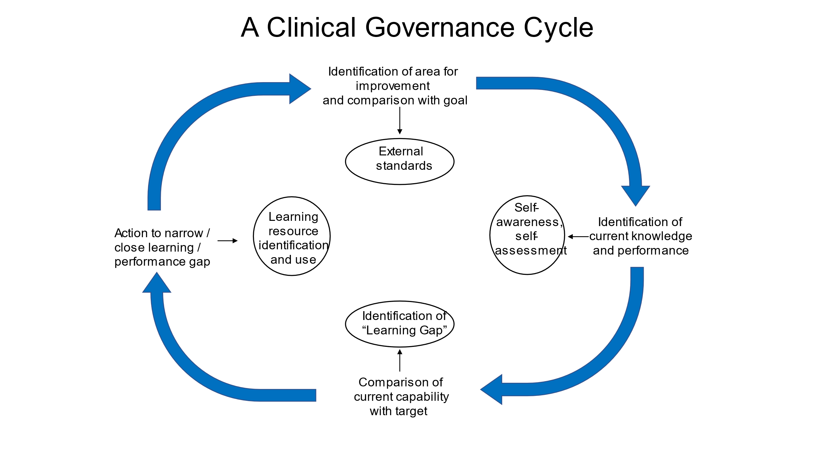

Below are extracts from the Code of Conduct in relation to clinical governance. This is a guide to show you the types of activities that would be elements of clinical governance cycles and should aid you in writing your statement.

Code of Professional Conduct for Veterinary Surgeons

1.7 Veterinary surgeons must ensure that clinical governance forms part of their professional activities.

6.1 Clinical governance is a continuing process of reflection, analysis and improvement in professional practice for the benefit of the animal patient and the client owner. This practical guidance is intended to help all veterinary surgeons and veterinary nurses to undertake clinical governance, whether they are in clinical practice, or not. Much of the advice for individual veterinary surgeons and veterinary nurses, and the veterinary team, will be covered in other parts of the Code and its supporting guidance.

Guidance for individual veterinary surgeons and veterinary nurses
6.2 Clinical governance may include:
- keeping up to date with continuing professional development (CPD) and new developments relevant to the area of work;
- reflecting upon performance, preferably in the form of a learning diary, and making appropriate changes to practice;
- reflecting upon any unexpected critical events and learning from the outcome and making appropriate changes to practice;
- critically analysing the evidence base for procedures used and making appropriate changes to practice;
- reflecting upon communication with other members of the work team and making appropriate changes to practice;
- reflecting upon communication with clients and making appropriate changes to practice; and,
- assessing professional competence in consultation with more experienced or better qualified colleagues and limiting your practice appropriately.

Guidance for the veterinary team
6.3 Clinical governance may include:
- Animal safety
  - In case of any critical event eg unexpected medical or surgical complications, serious complaint, accident or anaesthetic death, hold a no-blame meeting of all staff involved as soon as possible after the incident and record all the details.
  - At the critical event meeting consider what, if anything, could have been done to avoid this incident, and what changes can be made in procedure as a result.
  - Have clear protocols in place to ensure all staff are familiar with procedures for ensuring patient safety.
  - Communicate changes in procedure to the whole practice team.
  - Ensure staff are aware that referral (to an appropriate veterinary surgeon in the practice or another practice) is an option to the client.

- Clinical effectiveness
  - Organise regular clinical discussion meetings for the practice team, record minutes, and review any action points at future meetings. All clinical staff should be encouraged to participate and input items onto the agenda.
  - Follow up any clinical issues arising from clinical discussion meetings.
  - Make appropriate changes as a result of clinical discussion meetings and monitor these changes to ensure they are effective.
  - Organise online discussion forums to discuss clinical cases where geography or part-time working make face-to-face meetings difficult.
  - Organise practice team discussions on guidelines or protocols used in practice. Look at the evidence base for common procedures and treatments used in the practice and revise these as a result if necessary.
  - Build up a manual that can be used as clinical guidance in the practice. Make sure that it is regularly updated and new or temporary members of staff are made familiar with its contents at the earliest opportunity.
  - Organise clinical clubs or journal clubs, either live or online, critically discussing cases and clinical papers.
  - Audit the results of clinical procedures of interest to the practice team and use the results to improve patient care (see www.vetaudit.co.uk for more information).
  - Have a policy, with funding if possible, to encourage CPD for all veterinary surgeons and veterinary nurses and clinical support staff.
  - Have a system for individuals to feedback interesting information from CPD courses to the rest of the practice team.
  - Incorporate information learned at CPD courses into practice protocols, where appropriate.
  - Ensure clinical staff have access to suitable up-to-date reference material.
  - Have systems to ensure that information on new veterinary products or new pieces of equipment is communicated to the veterinary team.
  - Have a performance review system in place for all clinical staff to monitor and plan development.

- Patient and client experience
  - Ensure continuity of care for patients by having effective systems of case handovers between clinical staff.
  - Have protocols to safeguard the pain relief and nursing care for all inpatients.
  - Have an effective means of communicating with clients, eg newsletters, web sites etc.
  - Monitor and take note of feedback from clients.
  - Ensure that clients can easily find out the names of staff, eg badges, notice boards, web site etc.
  - Have protocols known to all relevant staff for dealing with members of the public.
  - Have a complaints procedure.
  - Record all complaints received and the responses to the clients.
  - Have an effective communication system within the practice.



RCVS Advanced Practitioners
Clinical Governance statement

Applicant Name:

RCVS Membership number:

An extract from the Code of Professional Conduct for Veterinary Surgeons is provided on pages 26-27.

Please describe the ways in which you have been involved with clinical governance, in line with the Code, illustrating your statement with two specific examples. You do not need to evidence every point in the Code, but choose two examples in which you have been personally involved and explain the impact that these have had on your practice. Ideally these examples should be from cases that were within your designation.

