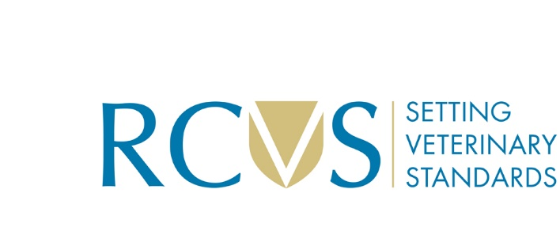

Application form for Fellowship Science Advisory Panel membership

Please complete all sections of this form

- Personal Information
Full Name
Email address
MRCVS number

- Qualifications
Qualification | Qualification title | Institution | Year achieved

- Research and Publications
Please provide details of your most significant research contributions and publications
Title of publication | Journal/Publisher | Year | Summary

- Professional Experience
Current or Most Recent Position:
Job title | Employer | Duration (From-To) | Main Responsibilities

Previous Positions:
Job title | Employer | Duration (From-To) | Main Responsibilities

- Skills and Abilities
Please describe your proficiency in the following areas:
Analytical and critical thinking skills; written and verbal communication skills; collaborative working; evaluation of scientific methodologies and data; knowledge of veterinary science advancements; understanding of ethical frameworks in veterinary research.

- Membership of Relevant Professional Bodies (if applicable)

- Declaration
I confirm that the information provided in this application form is accurate and complete to the best of my knowledge. I understand that any false statements or omissions may disqualify me from being considered for this position.

Signature:

Date:

Once completed, please return this form to Amymay Youngs, Senior Fellowship Officer, at fellowship@rcvs.org.uk

