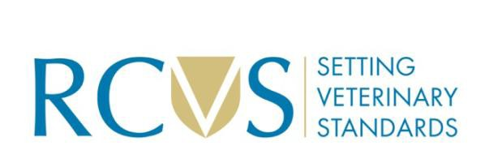
Synoptic Exam Application Form

Administrative details
Your name in full:
Surname:
First names:
Title: | Prof/Dr/Mr/Mrs/Miss/Ms

Designation
Membership number:
Name of the designation you are applying for, e.g., CertAVP (Equine Practice):

Designation:

Modules
Each candidate must have attained 60 credits in a combination appropriate to their chosen designation. For a second designation you must take at least one additional module.

Module | Code | Credits | University | Date awarded*
The RCVS may share data with accredited Universities and publish your achievements.
*Applications should be made once all modules have been assessed.

Payment
Please provide payment by bank transfer of £1175

Bank Name: Lloyds Bank
Bank Account Name: Royal College of Veterinary Surgeons-Fees a/c
Bank Account No: 01066656
Bank Sort Code: 309897

Please provide a Ref consisting of your Register Number and surname.

Statement
I DECLARE that the information provided in this application is true.
I understand I can only take one synoptic exam per year from any assessment provider
Signature: | Date:
Name (in block capital letters):
Contact details:
Once you have completed 60 credits in the relevant subjects: Please complete this form and return it, with payment, to certavp@rcvs.org.uk . This will mark the start of your synoptic application. RCVS will aim to offer at least one synoptic assessment series per year, depending on demand. RCVS may need to put candidates on a waiting list for assessment, to ensure that there are sufficient candidates presenting for a subject during any one series. There must be at least three candidates in each subject session. In the event of an assessment series being cancelled due to low candidate numbers, RCVS would aim to assess any waiting candidates at the next series, but not keep any candidate waiting for longer than 1 year.

Cancelations must be made more than one month before the examination.

