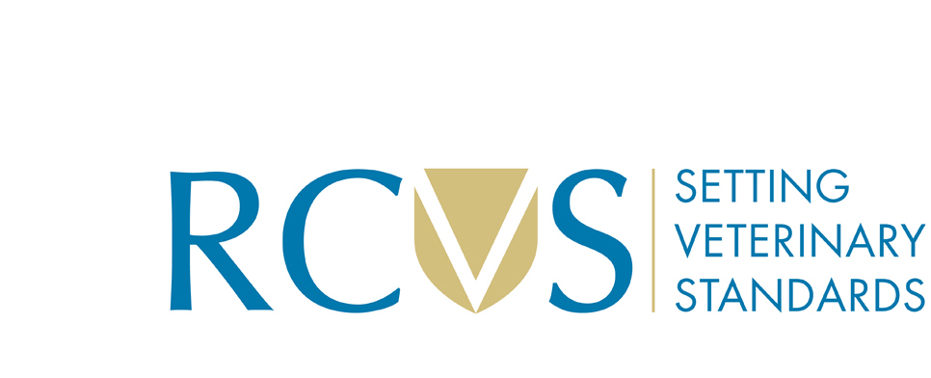

Conditions of supply of RCVS veterinary surgeon and veterinary nurse data

The data remains the copyright property of the RCVS and will only be supplied subject to the following conditions:

- The data is for your own use only and will only be used for the purpose of the project listed below and agreed by us, and is for bona fide non-commercial purposes only. Please describe below what this data will be used for.

- You agree to destroy the data, and any copies of the data, once the project has finished by no later than:

- You agree a veterinary surgeon and/ or a veterinary nurse will be contacted no more than time(s) from the date the data is supplied until the agreed date it is destroyed. (This must not equate to more than 1 mailing per individual per calendar month).

- You accept full responsibility for the security of the data and agree not to store it on a mobile device or send the data anywhere by email. You will notify the RCVS immediately when you have discovered a potential breach, in order for us to carry out an investigation and determine our reporting options.

- You will not copy or disclose the data in any form to a third party without the written permission of the RCVS.

- You accept full responsibility for holding the data under the terms of data protection legislation.

- You agree to give the RCVS a copy of any report or research that results from the use of the data, which we will treat confidentially if you request us to do so.

- You agree to assist the RCVS with its routine monitoring of mailings received by members and practices to ensure that no unauthorised use has been made of its copyright data.

- You undertake to ensure that the data is not used in conjunction with the College name, logo, crest or the letters “RCVS” such as to imply any RCVS endorsement of, or association with, your organisation or activity, unless this has been expressly agreed.

- RCVS requires that you provide a copy of valid ethnical approval for your research study, alongside this form when submitting your request for data.

- The data is believed to be accurate at the time it was supplied and the RCVS cannot accept responsibility for any errors, omissions or losses which may result from this.

Data requestor
I agree to the above conditions

Signature

Print name
Date


Authorised by the RCVS

Signature

Position
Date

Comments

